Some information about me and Weibo:

I am Zihan Qiao and from Hebei province, China. My program here is System, control and robotics and this is my second year. I worked for the Weibo account since July in 2020. I loved this job. First let me introduce Weibo.

Sina Weibo is a Chinese microblogging website. Launched by Sina Corporation on 14 August 2009, it is one of the biggest social media platforms in China, with over 445 million monthly active users. It is kind of like a Chinese version of twitter.

Many weibo followers are Chinese students and parents of them. They may be willing to apply for the KTH. Therefore, one important facet for the Weibo is some information about KTH and its application process and the introduction of several programs.

In addition, I also created many other topics on Weibo such as #KTH research#, #KTH cinema#, #Sweden notes gallery#. I also wanted to introduce Sweden culture in the Weibo account.

But the core point will still be application introduction about KTH.

Picture of Weibo:

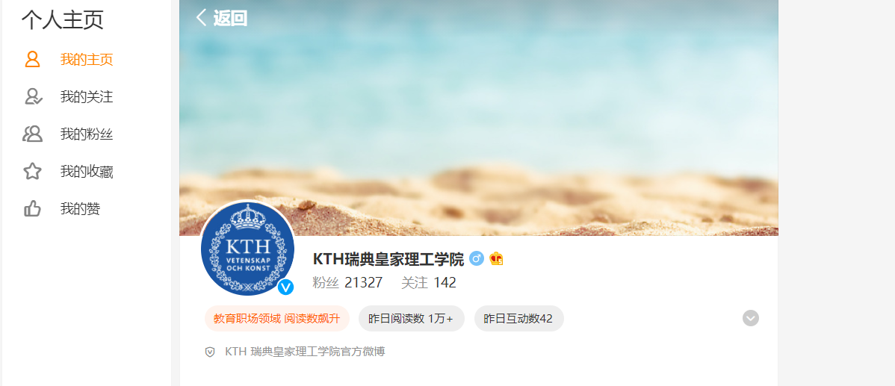

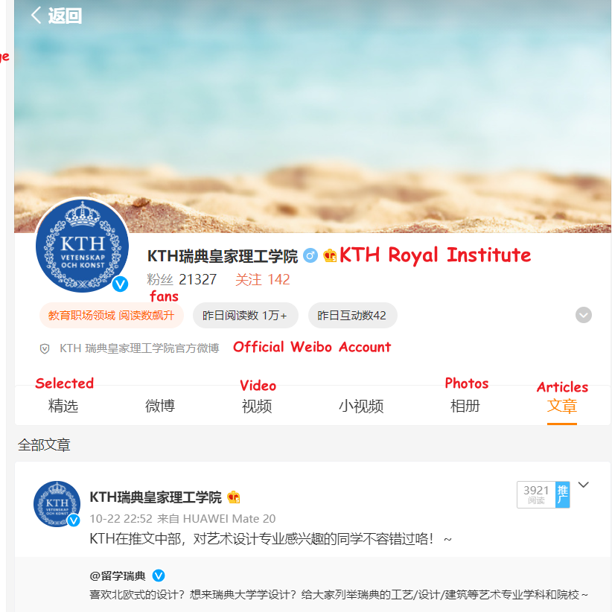

Picture of me:



